(Approx. 941 words)

Power USB
By Clint Tinsley, Editor, Idaho PCUG
December 2011 issue, Bits and Pieces
http://idahopcug.apcug.org/
c_tinsley (at) msn.com

In a presentation to the IPCUG a couple months back, I touched on some considerations in using the USB (Universal Serial Bus) connectors on your computer. This article will reinforce the points I made in that presentation but will go much further.

First, let’s talk about the laptop as the new desktop computer. The laptop offers many things a desktop system doesn’t offer out-of-box, such as webcam, built in speakers, touch pad, keyboard, and monitor, all in a package that is powerful, highly useful, and portable. However, one downside is that most all connections to the laptop are made using its USB Ports which are generally few in number, typically 3. I have a new netbook that only has 2 USB ports.

As an example desktop system and how I use USB, my work-at-home desktop computer is a HP ProBook 6455b, a small 14” notebook, standard keyboard without a keypad, and 3 USB ports. I have no less than 6 devices that must connect via USB for work.
1) Wireless Full sized Keyboard/Mouse
2) 2nd Display Monitor Adapter
3) USB Active Key for VPN Network Access
4) USB Powered Speakers
5) USB Powered Chiller Pad to keep the PC Cool.
6) USB Storage device.

With only 3 ports, I have to use 4 port hubs on one of the ports to connect to items 3 through 6. And I am still not done with devices I might need to connect such as a second DVD drive, card reader, or tablet. There are three things that need to be considered in using USB ports, damage control, USB power, and USB port speed, which I will cover in that order.

Damage Control
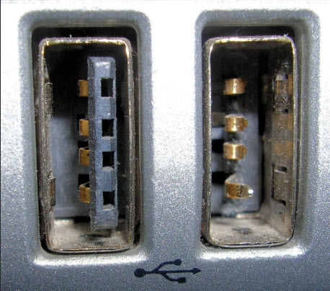
Shown right are the 2 USB ports on one of my laptops. One is usable, one is obviously not! The left port is still good and normal in appearance. The right port is unusable due to the connector material being busted out and the 4 connectors hanging out in space; I don’t know how this happened but I strongly suspect that something plugged into that port was struck hard enough to break it. I really recommend against plugging any large sized devices into the USB ports that could damage the ports if accidentally struck or leaned on, which can also damage the internals of the computer. The picture below shows a short extension cable that can greatly reduce that kind of damage from occurring.
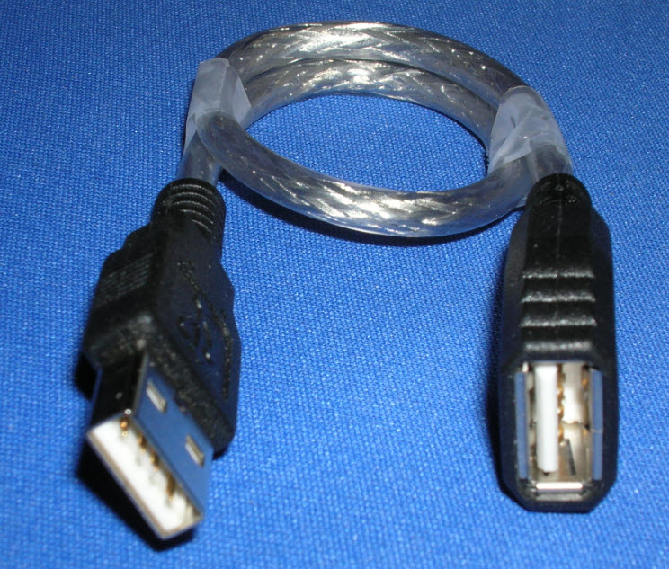

Power Management
The USB 2.0 specification limits the current available per port to 500 mA, or .5A, which is half an amp of current. This is not enough current to run some USB devices such as USB DVD Drives and External Hard Drives, even the “pocket” sized ones. Vendors of hubs, DVD drives and USB drives get around this power limitation supplying a cable that uses 2 USB Ports on your laptop, one for data/power and second for power in order to provide enough power for the device itself and anything else that might be plugged into it. In well-designed laptops, each USB port is supposed to be limited by a Vbus power controller, isolating the 5V on the USB port from the laptop, providing some protection to the computer, but this may not be the case in all laptops and further damage or overheating can occur. The solution to this problem is the use of an externally powered USB hub that has its own AC power supply. Unfortunately, many USB hubs don’t come with a power supply even though they have a jack for which to plug in a power supply. One such 7 port hub I showed at the meeting is the Ativa® Mobil-IT™ 7-Port USB 2.0 Desktop Hub with a 3.5 amp power supply (Seven times .5A!), which I had purchased at Office Depot for $25.99 (SKU 196179). A search of Amazon reveals a number of 4 to 7 port USB hubs with power supplies from a few dollars on up. It is very important that when buying a USB Hub is to make sure it comes with its own power supply.

USB Speed or the need for Speed!
You may be fortunate enough to get one of the new laptops with a 3.0 USB port. These new ports are capable of speeds up to 5 GB/second! Compare that to 480Mbps for high speed 2.0 ports and down to 12 Mbps for legacy 1.1 ports on older computers. Note that the 480MBs is a per port specification and when you connect a hub into a USB port and depending on the devices plugged into hub, overall speed through the hub is limited to 480 Mbps, so don’t try to play a DVD, use an USB Hard Drive, and a thumb drive, all at the same time. If you shop around and get one of the new 3.0 hubs with an external power supply, you will be blessed with great speed on all the ports, just make sure you plug it into a 3.0 port on your laptop. My personal laptop has 4 USB ports, the two 3.0 ports which are distinguished by a dark blue colored insulation material on the contacts (such as in the picture below). The 2.0 ports have a black insulation material. One other advantage of using powered hubs is that they can be used to charge up USB devices like MP3 players without having to turn on a computer or leave it on just to charge a device.

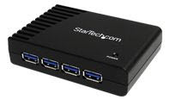

StarTech.com 4 Port Black SuperSpeed USB 3.0 Hub $42 (with Power Supply)

